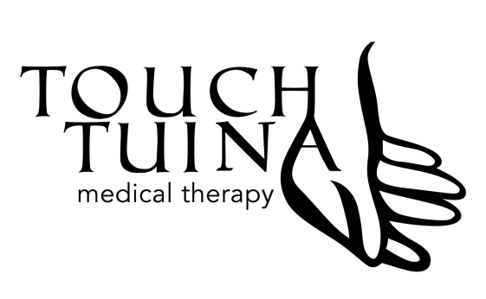
Touch Tuina Medical Therapy Centre

46 Malden Road, London, NW5 3HG
Tel: 020 3623 2952
Email: info@touchtuina.com
Website: www.touchtuina.com

__________________________________________________________________________________

STUDENT TO MASTER REGISTRATION FORM

First name: ……………………………………………….. Last name: ……………………………………………….

Date of Birth: ……………………………………………. Gender: M / F

Postal address: ………………………………………….

…………………………………………………………………… Postcode: …………………………………………………

Email address: ………………………………………….. Mobile number: ……………………………………….

Nationality:

Place of birth:

Do you require a visa: Yes No

Do you have a Student or Full Insurance: (please specify)

Qualification: (please specify)
Diploma Level 3 in Anatomy and Physiology ITEC in Anatomy and Physiology

Any Experience:
Level of Body Work, Health or Chinese Medicine Training:

School, Courses, Qualifications or Study in Massage or Body Work:

School, Courses, Qualifications or Study in Tuina:

What have you covered/Your Level:

General Massage Sports Massage Orthopaedic

Prone Supine Seated

What Course /Workshop are you interested in learning? (Please tick)

Tuina Chinese Medical Massage

Tuina Reflexology

Cupping Therapy

TCM Basic Therapy (Lectures)

Tuina Facial Massage

Dietary Therapy Workshop

Other (please specify)…..

Hand Techniques/Forearm + Calf Massage

Prone Routine
Supine Routine
Seated Routine

Orthopaedic

Shoulder Ankle
Neck Feet
Elbow Foot Massage
Knee Basic
Back

Do you have a medical history that Touch Tuina should be aware of (i.e.: epilepsy, allergies, diabetes, medications, etc.)?

This course contains physical Hands on sessions where you will be working in pairs throughout the day. Please let us know if you have any pre-existing medical conditions (bad back, disability, etc)

Students are also required to attend clinic days to achieve the minimum hours (200 hours). This will be one day a week after the start of the course, week beginning March 5/6 2016 to February 2017. Please choose one of the days below, and then you will need to confirm your weeks with the Receptionist.

Monday Tuesday Wednesday Thursday Friday Saturday

PAYMENT:

Deposit of £250.00

Full payment of £3000.00

Instalment payment plan

